**DAILY ONLINE ACTIVITIES SUMMARY**

|  |  |  |  |  |  |  |  |
| --- | --- | --- | --- | --- | --- | --- | --- |
| **Date:** | **23/06/2020** | | | | **Name:** | **Churashma** | |
| **Sem & Sec** | **4th SEM 'A' Section** | | | | **USN:** | **4AL18CS019** | |
| **Online Test Summary** | | | | | | | |
| **Subject** | | **No test** | | | | | |
| **Max. Marks** | | **-** | | **Score** | | **-** | |
| **Certification Course Summary** | | | | | | | |
| **Course** | **Introduction to R** | | | | | | |
| **Certificate Provider** | | | **greatlearning academy** | **Duration** | | | **3.5 hours** |
| **Coding Challenges** | | | | | | | |
| **Problem statement 1: Write a C Program to Sort a stack using a temporary stack.**  **Problem statement 2: Python Program to Split the array and add the first part to the end There is a given an array and split it from a specified position, and move the first part of array add to the end.** | | | | | | | |
| **Status: completed** | | | | | | | |
| **Uploaded the report in Github** | | | | **yes** | | | |
| **If yes Repository name** | | | | **https://github.com/Churashma/Lockdown-coding** | | | |
| **Uploaded the report in slack** | | | | **yes** | | | |

ONLINE TEST DETAILS: No test.

CERTIFICATION COURSE DETAILS: Today I studied about exporting data in R. Loading data into R can be quite frustrating. Almost every single type of file that you want to get into R seems to require its own function, and even then you might get lost in the functions’ arguments. In short, it can be fairly easy to mix up things from time to time, whether you are a beginner or a more advanced R user.

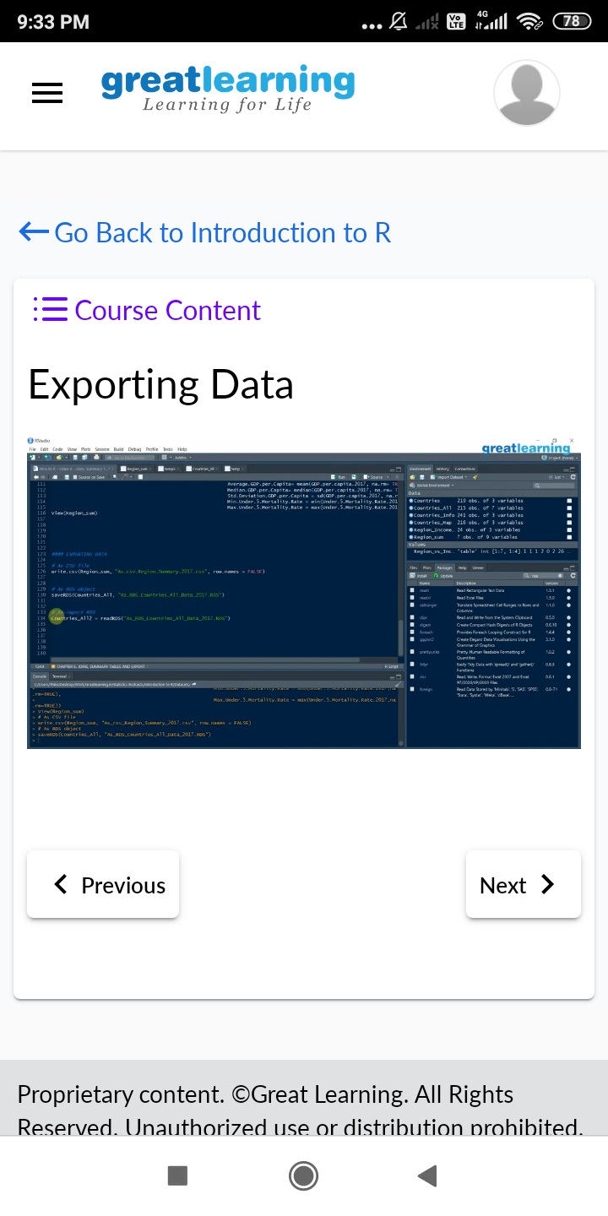

**CODING CHALLENGES DETAILS**:

Problem statement 1: Write a C Program to Sort a stack using a temporary stack.

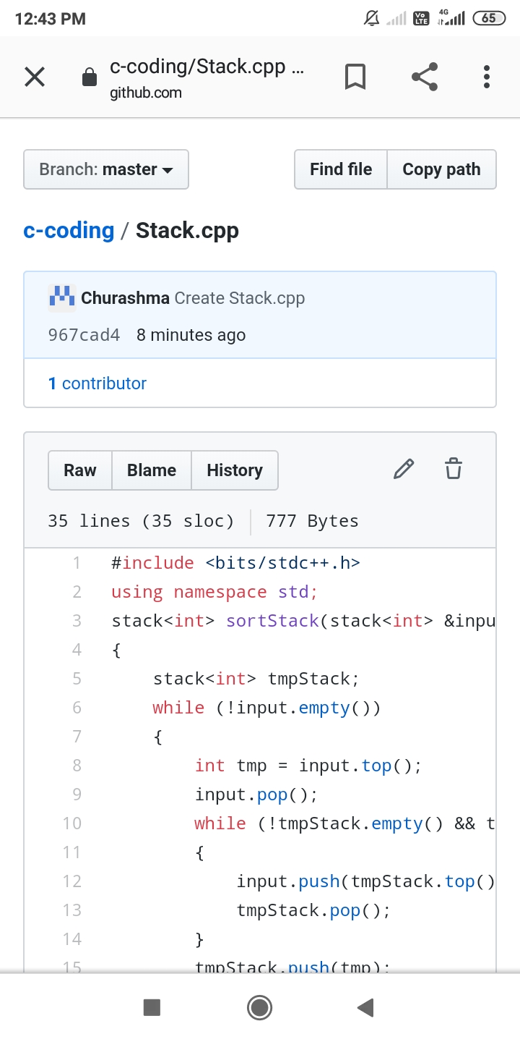

Problem statement 2: Python Program to Split the array and add the first part to the end There is a given an array and split it from a specified position, and move the first part of array add to the end.

